**Serverless Querying of CSV Data in S3 Using AWS Athena**

**Objective**

To query structured data stored in an Amazon S3 bucket using SQL — without deploying or managing a traditional database system — by leveraging AWS Athena, a serverless interactive query service.

**Steps Performed**

**Step 1: Upload CSV File to S3**

* File uploaded to: s3://manan-movie-review/IMDB Dataset.csv

**Step 2: Open AWS Athena Console**

**Step 3: Set Query Result Location**

* Set result output to: *s3://manan-movie-review* under **Setting**



**Step 4: Create Database**

***CREATE DATABASE IF NOT EXISTS my_csv_db;***

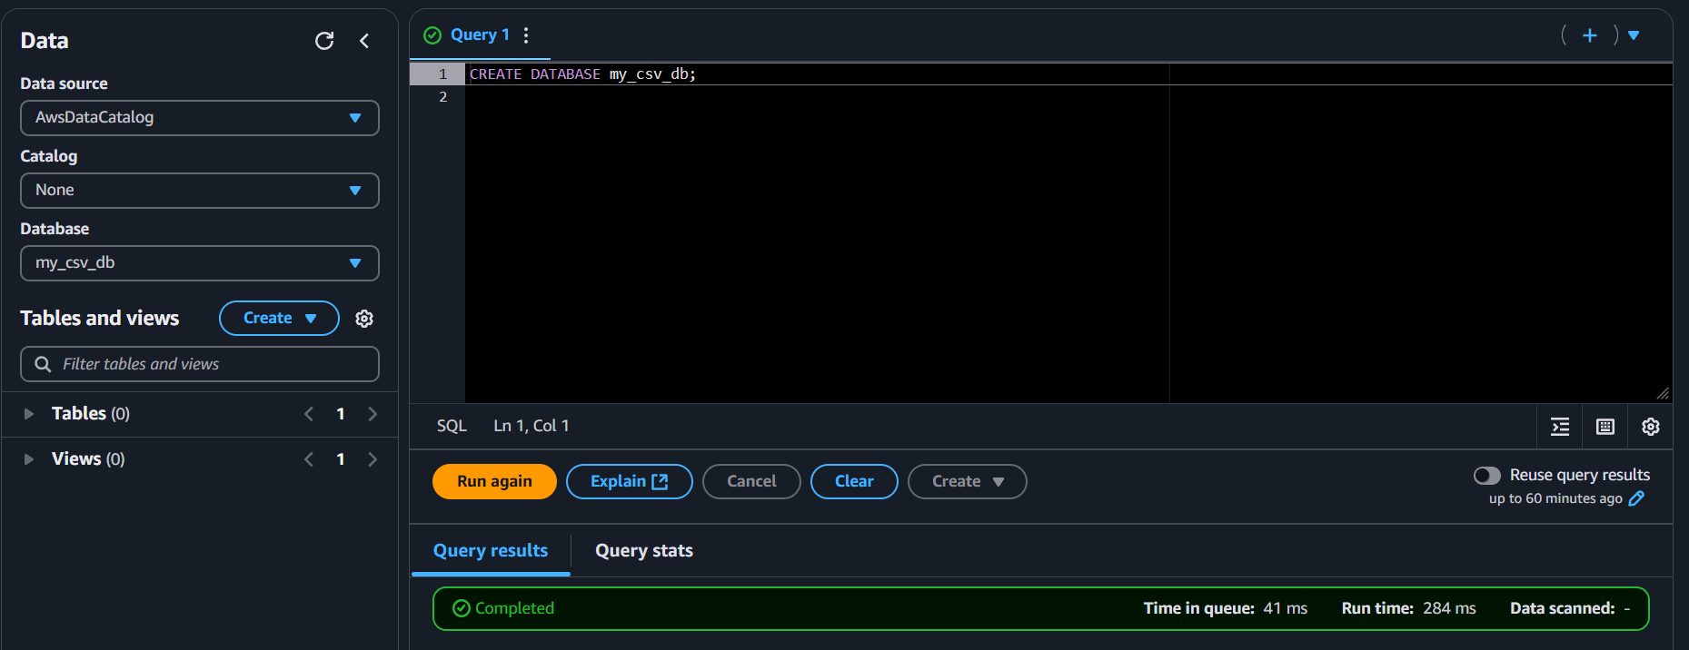

**Step 5: Create External Table**

***CREATE EXTERNAL TABLE IF NOT EXISTS movie_reviews (***

***review STRING,***

***sentiment STRING***

***)***

***ROW FORMAT SERDE 'org.apache.hadoop.hive.serde2.lazy.LazySimpleSerDe'***

***WITH SERDEPROPERTIES (***

***'serialization.format' = ',',***

***'field.delim' = ','***

***)***

***STORED AS TEXTFILE***

***LOCATION 's3://manan-movie-review/'***

***TBLPROPERTIES (***

***'skip.header.line.count' = '1'***

***);***

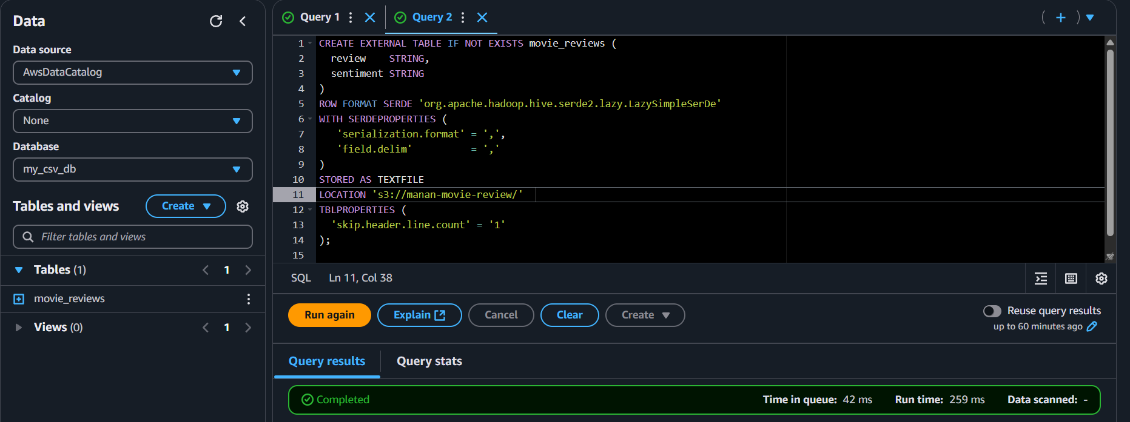

**Step 7: Query the Table**

***SELECT * FROM movie_reviews LIMIT 10;***

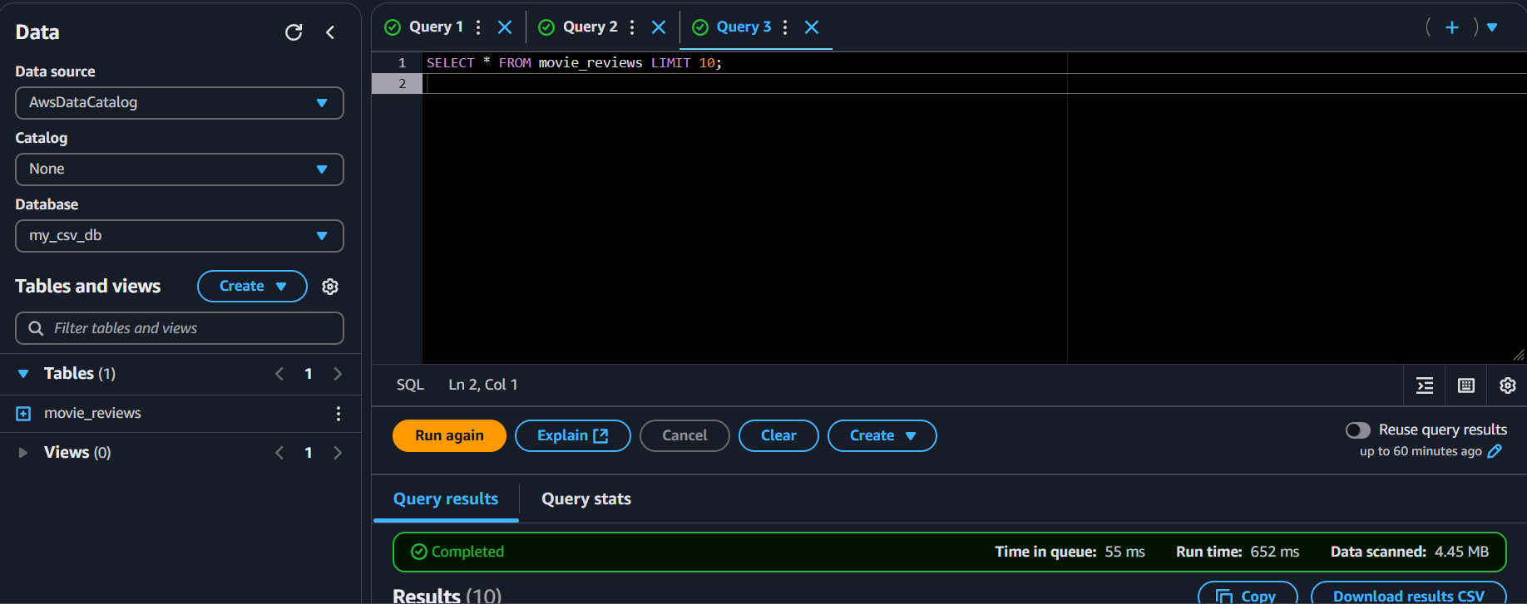

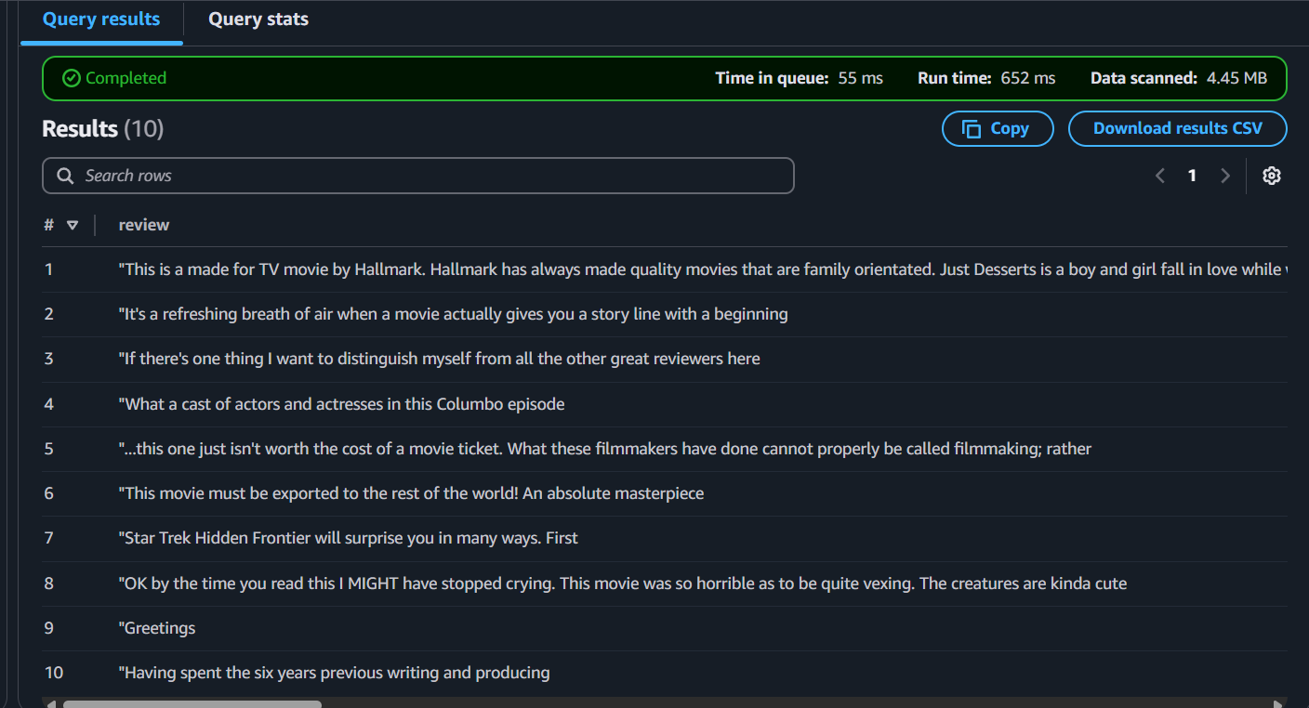

**Outcome**

* Successfully queried structured data from S3 using Athena without provisioning any database engine.